**E91 Cloud Devops: Fall 2018**

**Assignment 6**

**Stephen Akaeze**

Instruction Manual: <https://canvas.harvard.edu/courses/53026/files/6906054/download?verifier=95SDq1EMc7sqQVsYS7xQlEhECxSkn6Xb6hmJxnnJ&wrap=1>

Problem 1

1. The VIM was created and was successfully logged into as demonstrated below
   1. SSH Access

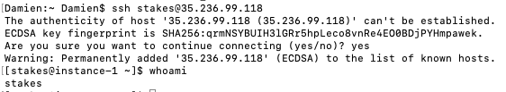

* 1. Browser access

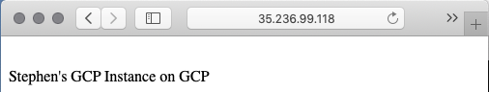

1. To create 3 instances of the same server I would do the following
   1. Create Instance Templates
      1. compute engine -> instance templates -> select machine type -> select boot disk -> allow default access -> create (name: ITGROUP)
   2. Create Instance Group
      1. compute engine -> Instance groups -> select region -> select zone -> select instance (ITGROUP) -> select what autoscale is based on ->enter number of instance (3) -> Create